B.Sc(Hons) Computer Science Assignments Java Programming 2018
(1) Explain what will happen when you run this program-
package main;

// filename Main.java
class Point {
protected int x, y;

public Point(int _x, int _y) {
x = _x;
y = _y;
}
}

public class Main {
public static void main(String args[]) {
Point p = new Point();
System.out.println("x = " + p.x + ", y = " + p.y);
}
}

(2) // filename Main.java
class Grandparent {
public void Print() {
System.out.println("Grandparent's Print()");
}
}

class Parent extends Grandparent {
public void Print() {
System.out.println("Parent's Print()");
}
}

class Child extends Parent {
public void Print() {
super.super.Print(); // Trying to access Grandparent's Print()
System.out.println("Child's Print()");
}
}

public class Main {
public static void main(String[] args) {
Child C = new Child();
C.Print();
}
}

(3) What will be the output of the program?

class MyThread extends Thread
{
public static void main(String [] args)
{
MyThread t = new MyThread();
t.start();
System.out.print("one. ");
t.start();
System.out.print("two. ");
}
Public void run()
{
System.out.print("Thread ");
}
}

(4) What will be the output of the program?
class MyThread extends Thread
{
MyThread() {};
MyThread(Runnable r)
{
super(r);
}
public void run()
{
System.out.print("Inside Thread ");
}
}
class MyRunnable implements Runnable
{
public void run()
{
System.out.print(" Inside Runnable");
}
}
class Test
{
public static void main(String[] args)
{
new MyThread().start();
new MyThread(new MyRunnable()).start();
}
}

(5) What will be the output ?

class Test {
public int aa = 1;
public Test (int i)
{
aa += i;
}
}
class Sample extends Test
{
public Sample (int i)
{ super(i); aa += i;
}
}
class E
{
public static void main (String argv[])
{
Test ar[] = new Test[2];
ar[0] = new Test(1);
ar[1] = new Sample(2);
System.out.println(ar[0].aa + ar[1].aa);
}
}

(6) Given:
public class MyStuff {
String name;
MyStuff(String n) {
name = n;
}
public static void main(String[] args) {
MyStuff m1 = new MyStuff("guitar");
MyStuff m2 = new MyStuff("tv");
System.out.println(m2.equals(m1));
}
public boolean equals(Object o) {
MyStuff m = (MyStuff) o;
if (m.name != null) {
return true;
}
return false;
}
}

What is the result?

(7) public class MyLoop {
public static void main(String[] args) {
String[] sa = {"tom ", "jerry "};
for (int x = 0; x < 3; x++) {
for (String s : sa) {
System.out.print(x + " " + s);
if (x == 1) {
break;
}
}
}
}
}
What is the result?

(8) Given:
class Feline {
public String type = "f ";
public Feline() {
System.out.print("feline ");
}
}
public class Cougar extends Feline {
public Cougar() {
System.out.print("cougar ");
}
void go() {
type = "c ";
System.out.print(this.type + super.type);
}
public static void main(String[] args) {
new Cougar().go();
}
}

(9) What does the following program do? What will be the output?
class Mystery{
int result;
void init(){
int a[] = {1,2,3,4,5,6,7,8,9,10};
result = WhatIsThis(a, a.length);
System.out.println(“Result is: “ + result);
}
int WhatIsThis(int b[], int size)
{
if (size == 1)
return b[0];
else
return b[size-1] + WhatIsThis(b, size-1);

(10) What will happen when this program is run?
public class Main {
public static void main(String args[]) {
// some other stuff
try {
// Some monitored code
throw new Derived();
}
catch(Base b) {
System.out.println("Caught base class exception");
}
catch(Derived d) {
System.out.println("Caught derived class exception");
}
}
}

(11) Predict the output of following Java program. Assume that int is stored using 32 bits.
class Test {
public static void main(String args[]) {
int x = -1;
System.out.println(x>>>29);
System.out.println(x>>>30);
System.out.println(x>>>31);
}
}

(12) What will be the output?
class Test {
public static void main(String args[]) {
System.out.println(10*20 + "GeeksQuiz");
System.out.println("GeeksQuiz" + 10*20);
}
}

(13) class Test
{
public static void main(String args[])
{
String s1 = "geeksquiz";
String s2 = "geeksquiz";
System.out.println("s1 == s2 is:" + s1 == s2);
}
}

PROGRAMMING EXERCISES ON MULTITHREADING:

(14) Read and understand the following program which uses Multithreading carefully. Then write the Multithreaded programs for the problem given below
(1) /**
* This thread finds the sum of a subsection of an array.
*/
public class SumThread extends Thread {
private int lo, hi;
private int[] arr;
private int ans = 0;

public SumThread(int[] arr, int lo, int hi) {
this.lo = lo;
this.hi = hi;
this.arr = arr;
}

public void run() {
for (int i = lo; i < hi; i++) {
ans += arr[i];
}
}

/**
* Sum the elements of an array.
*
* parameter arr array to sum
* return sum of the array's elements
* throws InterruptedException shouldn't happen
*/
public static int sum(int[] arr) throws InterruptedException {
int len = arr.length;
int ans = 0;

// Create and start 4 threads.
SumThread[] ts = new SumThread[4];
for (int i = 0; i < 4; i++) {
ts[i] = new SumThread(arr, (i * len) / 4, ((i + 1) * len / 4));
ts[i].start();
}

// Wait for the threads to finish and sum their results.
for (int i = 0; i < 4; i++) {
ts[i].join();
ans += ts[i].ans;
}
return ans;
}
(15)Max value

Write a program called MaxValue.java that finds the maximum value in an array of ints using 4 threads. Your main should be similar as the one in the above-linked SumThread example, though you should construct your array of random numbers instead of increasing numbers. You may assume in your threaded code that the array has at least 4 elements.

(16) Reverse hello

Write a program called ReverseHello.java that creates a thread (let's call it Thread 1). Thread 1 creates another thread (Thread 2); Thread 2 creates Thread 3; and so on, up to Thread 50. Each thread should print "Hello from Thread <num>!", but you should structure your program such that the threads print their greetings in reverse order.

(17) Shared counter
Write a program called SharedCounter.java in which 10 threads each increment a shared int counter 10 times. When all the threads have finished, print the final value of the counter. If the initial value is zero, do you always get 100

Programming Exercises on Applet and AWT

(18) Develop an applet which consists of a canvas and two choice boxes. The applet will draw coloured circles on the canvas. A circle can be blue, green or red and can be a small, medium or large circle. A small circle is 2 pixels in diameter, a medium circle is 5 pixels in diameter and a large circle is 10 pixels in diameter. The choice of colour and type of circle is determined by the two choice boxes that are to be added to the applet. You will therefore need to add a choice box which has red, green and blue choices and a choice box which has small, medium and large choices. When a user clicks on the canvas with the mouse the circle is drawn at the click position and will be drawn according to the current selection of the choice boxes.

(19) AWT GUI Applications/Applets
AWTCounter
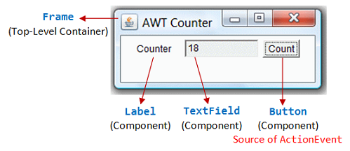
(20) Write an AWT GUI application (called AWTCounter) as shown in the Figure. Each time the "Count" button is clicked, the counter value shall increase by 1.
The program has three components:
- a java.awt.Label "Counter";
- a non-editable java.awt.TextField to display the counter value; and
- a java.awt.Button "Count".
The components are placed inside the top-level AWT container java.awt.Frame, arranged in FlowLayout.

(21) AWTAccumulator
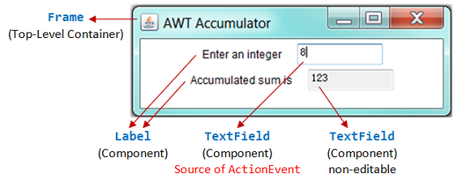
Write an AWT GUI application called AWTAccumulator, which has four components:
- a java.awt.Label "Enter an integer and press enter";
- an input java.awt.TextField;
- a java.awt.Label "The accumulated sum is", and
- a protected (read-only) java.awt.TextField for displaying the accumulated sum.
The four GUI components are placed inside a container java.awt.Frame, arranged in FlowLayout. The program shall accumulate the numbers entered into the input TextField, and display the accumulated sum on the display TextField.

(22) AWTAccumulatorApplet
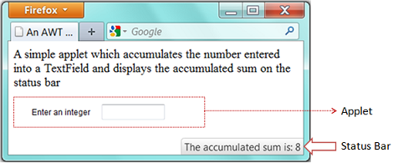
An Java applet is a graphics program run inside a browser. Write a Java applet (called AWTAccumulatorApplet) which contains:
- a label "Enter an integer:",
- a TextField for user to enter a number.
- The applet shall accumulate all the integers entered and show it on the status bar of the browser's window.

(23) Write an applet that shows a pair of dice. When the user clicks on the applet, the dice should be rolled (i.e, the dice are assigned newly random values). Each of the dice should be drawn as a square showing from 1 to 6 dots. Write a subroutine, "void drawDie(Graphics g, int val, int x, int y)", to draw a die at the
specified (x,y)coordinates. The second parameter, val, specifes the value that is
showing on the die. Assume that the size of the
applet is 100 by 100 pixels.

(24)Improve your dice applet from the previous exercise so that it also responds to keyboard input. When the applet has the input focus, it should be highlighted with a colored border, and the dice should be rolled whenever the user presses a key on the keyboard. A part of that, the dice still rolls when the user clicks the mouse on the applet.

(25)Instead of using keyboard and mouse to roll the dices as above, using a canvas to store the dice and place a "Roll" button below the canvas to roll the dice each time the user clicks on it.

(26)Modify the Checkboard.java given below to write a checkerboard applet where the user can select a square by clicking on it. Highlight the selected square by drawing a colored border around it. When the applet is first created, no square is selected. When the user clicks on a square that is not currently selected, it becomes selected. If the user clicks the square that is selected, it becomes unselected. Assume that the size of the applet is 160 by160 pixels,so that each square on the checkerboard is 20 by 20 pixels.

?

